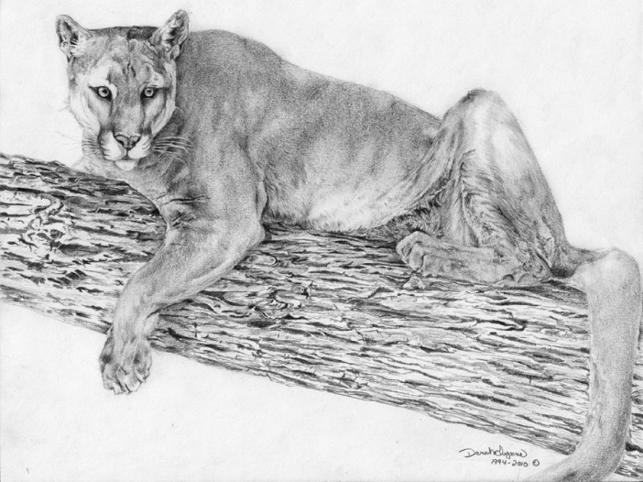
Northview Academy
1st Semester: Environmental Science
2nd Semester: Biology I
Syllabus 2019-2020
Instructor: Crystal Yates, Science Department
Room: B 120
Web site: http://nvamrsyates.weebly.com/
E-mail: crystalyates@sevier.org
Northview Academy phone: 933-5880

Class Description: This is a laboratory science course that investigates the science of life. You, the student, will better understand your role in preserving the natural environment and sustaining life on Earth as you study the relationship between the biotic and abiotic components in the environment and mechanisms that lead to population changes over time. You will study the relationship of form and function from the cellular level to organisms and systems. You will also take an inquiry-based approach through hands-on learning, academic articles and research.
Link to Standards: https://www.tn.gov/content/dam/tn/stateboardofeducation/documents/massivemeetingsfolder/meetingfiles4/10-20-17_III_J_Non-Substantive_Changes_to_Math_ELA__Science_Standards_Attachment_3_-_Science.pdf

Text: Tennessee Biology, Pearson Science is an introductory high school text that covers the major concepts of biology I. It applies concepts from biology I to all forms of life, particularly plants and animals. Textbooks will be issued to each student. It is your responsibility to keep the book in excellent condition and return it at the end of the course. The replacement cost is $99.97.

Materials needed: The following items are materials that will be needed in my class. If you are unable to purchase any of these items, please let me know so that arrangements can be made. If you are able to purchase any extra items for our class, it would be much appreciated, but please do not feel obligated to do so.
- Pocket folder to keep notes and graded papers
- Box of 12 colored pencils
- Loose Leaf Notebook Paper
- Pencils & Black or Blue Pens

Grading Policy: My grading policy will be consistent with the Sevier County Board of Education Policy, as outlined in the student handbook. Your daily average (class work, homework and quizzes) will be two-thirds of your grade, and your test average will be one-third of your grade. It is very important that you complete and hand in all assignments given by their due date in order to receive credit. I will accept one late assignment for full credit. Any late assignment following will be taken for half-credit. I would like to emphasize that it is your responsibility to collect any make-up work you have missed due to absences, and you will have one day to turn in the work for every excused absence you have acquired. Due dates given for long term assignments are due the day assigned with no exceptions, including excused absences.

Grading Scale: Grade Range Points
A 93-100 4.0
B 85-92 3.0
C 75-84 2.0
D 70-74 1.0
F 0-69 0.0

Classroom Expectations & Consequences: I expect all students to act respectfully, be responsible, and come prepared. Within each of these three expectations there are several criteria that must be met. Specific criteria include being ready to learn and in your seat when the bell rings, contributing to class discussions, turning in homework on time, etc. I feel confident that you will be able to meet and exceed the expectations that have been listed, but if for any reason you are unable, you will then have consequences to face. Consequences include but are not limited to: reminder of expectation, note and/or call to parent by teacher, and referral to principal. Please refer to the Student Behavior Code in the student handbook for a list of detailed consequences for specific behavior violations.

In addition, each student is expected to budget his/her time appropriately. Students will be reading at least one chapter a week from our textbook. You will be taking notes from the document projector, power point presentations, and verbal lecture. Your study and long term memory skills will be sharpened, as well as listening and note taking skills.

Each student will actively participate in laboratories and assigned dissections. Students will be assigned to a “dissection/ lab/ test team.” Students will assist in all facets of lab and exams given to their group during these activities. Students will be required to keep a notebook (class / lab) that details not just the work done but insight and knowledge gained as a result of working on actual specimens.

Reminder of Important School Policies:
- You must be in class when the bell rings. NOT just your stuff!
- Only one student can leave the classroom at a time. Each time a student leaves he/she must sign out.
- Cell phones are not allowed in class. See additional cell phone policy contract.
- Food or drink is not permitted unless it is water.

COURSE OUTLINE: Due to the length of this course, several of the chapters will be combined and outlined for you by the instructor.
______________________________________________________________________
1ST SIX WEEKS
Chapter 1 The Science of Biology
Chapter 3 The Biosphere
Chapter 4 Ecosystems
_____________________________________________________________
2nd SIX WEEKS
Chapter 5 Populations
Chapter 6 Communities and Ecosystem Dynamics
Chapter 7 Humans and Global Change
________________________________________________________________
3rd SIX WEEKS
Chapter 2 The Chemistry of Life
Chapter 8 Cell Structure and Function
Chapter 9 Photosynthesis
________________________________________________________________________
4th SIX WEEKS
Chapter 10 Cellular Respiration
Chapter 11 Cell Growth and Division
Chapter 12 Introduction to Genetics
Chapter 13 DNA
________________________________________________________________________
5th SIX WEEKS
Chapter 14 RNA and Protein Synthesis
Chapter 15 The Human Genome
Chapter 16 Biotechnology
Chapter 17 Darwin’s Theory of Evolution
________________________________________________________________________
6th SIX WEEKS
Chapter 18 Evolution of Populations
Chapter 19 Biodiversity and Classification
Chapter 20 History of Life
Dissections (examples: earthworm and frog) Virtual labs are also an option.

Final Exam: Environmental Science (first semester) will have a final exam in December. The final exam for Biology I will be the End Of Course exam (EOC) and will be taken in the spring.

Projects
Projects will be divided into required and extra credit categories. Due dates will be posted on the class calendar.

Extra credit: Biome in a bottle, How to help the environment poster, Mitosis 3-D model

______________________________________________________________
Student Name Date Period

______________________________________________________________
Parent Signature

